The Lion's Tale
Volume 1, Issue 4 November 2016
Samaritan’s Purse

Learning to give

Information for the Samaritan’s Purse web site https://www.samaritanspurse.org/our-ministry/about-us/

The story of the Good Samaritan (Luke 10:30-37) gives a clear picture of God’s desire for us to help those in desperate need wherever we find them. After describing how the Samaritan rescued a hurting man whom others had passed by, Jesus told His hearers, “Go and do likewise.” For over 40 years, Samaritan’s Purse has done our utmost to follow Christ’s command by going to the aid of the world’s poor, sick, and suffering. We are an effective means of reaching hurting people in countries around the world with food, medicine, and other assistance in the Name of Jesus Christ. This, in turn, earns us a hearing for the Gospel, the Good News of eternal life through Jesus Christ.
As our teams work in crisis areas of the world, people often ask, “Why did you come?” The answer is always the same: “We have come to help you in the Name of the Lord Jesus Christ.” Our ministry is all about Jesus—first, last, and always. As the Apostle Paul said, “For we do not preach ourselves, but Jesus Christ as Lord, and ourselves as your servants for Jesus’ sake” (2 Corinthians 4:5, NIV).

Mission Statement
Samaritan’s Purse is a nondenominational evangelical Christian organization providing spiritual and physical aid to hurting people around the world. Since 1970, Samaritan’s Purse has helped meet needs of people who are victims of war, poverty, natural disasters, disease, and famine with the purpose of sharing God’s love through His Son, Jesus Christ. The organization serves the church worldwide to promote the Gospel of the Lord Jesus Christ.

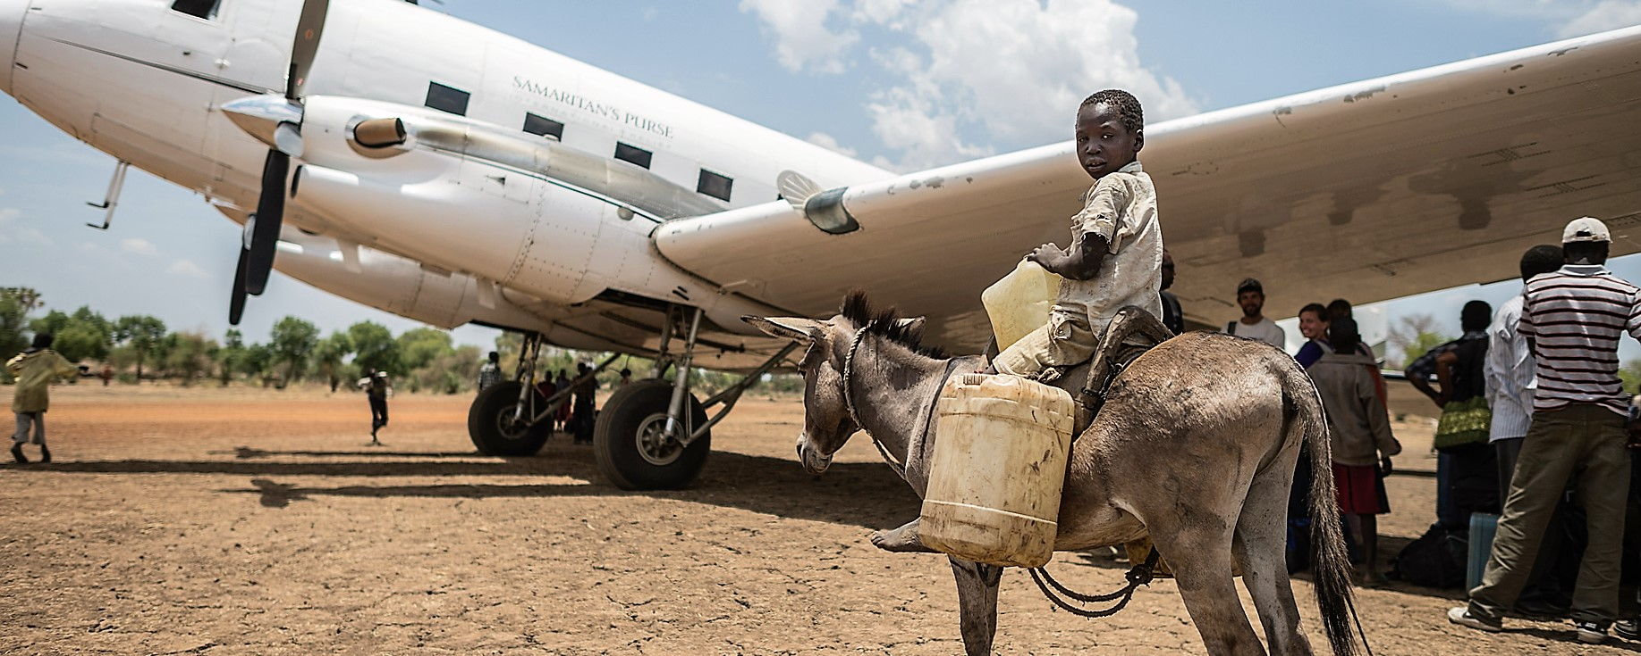
Faith Christian School is a proud supporter of this ministry. Students learn to love and give outside of their own small boundaries, and get the awesome privilege of participating in the Great Commission.

Community Helpers

FCS students learn of community helpers
Students of FCS enjoyed a day with firefighters, police, sheriff, woodland firefighters, the health department, Sacred Heart Hospital, and Florida Wildlife Commission learning about their role in our community. The staff and students of FCS extend heartfelt gratefulness to these brave men and women who serve to keep us safe and healthy. Thank you to each organization who came out for this awesome learning experience.

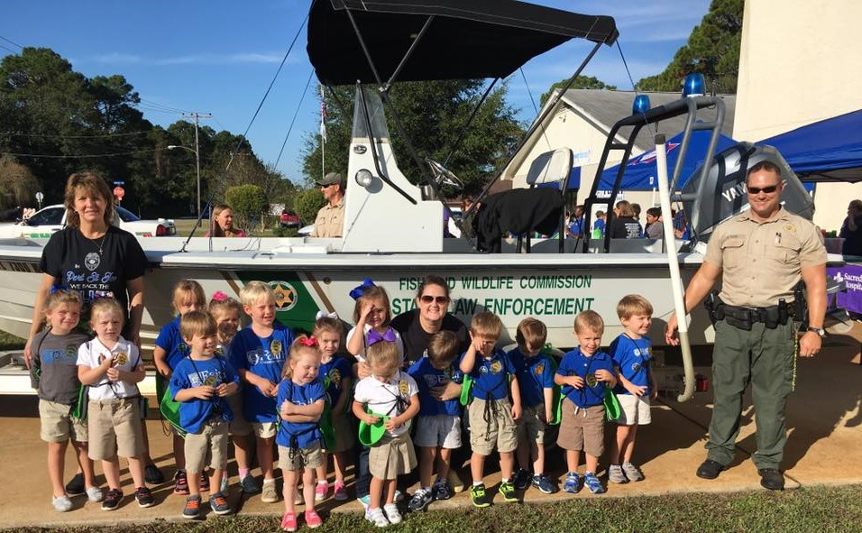

School Improvements

Making FCS a safer place

As you may already know, the staff and administration of Faith Christian School have been working all summer along with the PSJ Police Dept. and Gulf Co Sherriff’s Dept. to make our campus safer for everyone. We now have a new emergency plan including emergency evacuations and lockdown procedures. Now we are considering replacing the doors in Marvin Wing with fire proof doors with safety wired glass. We are also considering a security camera system to monitor
all entrances leading into the school. A long-term goal includes a new door locking system as well.

-School Improvements cont.
These things will bring peace of mind to all those that FCS services, but do not come cheap. The new
doors for Marvin Wing will cost right at $5,000.00 and the security system another $3,200.00. With tuition one of the lowest in the state of Florida and with regular building maintenance, FCS does not have the money for these things in reserve. If you are interested in giving a donation towards one of these items, please talk to Carla McGhee. Any amount will be appreciated and everything we can do in this changing world to make our school a safer place is a good investment for the future and our children.

Field Day

A day of fun and exercise

FCS students took a day from the books and celebrated good health and exercise with Field Day. Mrs. Tiffany Lee did an amazing job planning fun activities for all grade groups and a great time was had by all.
Thank you to everyone who volunteered, giving of your time, and making FCS the best!

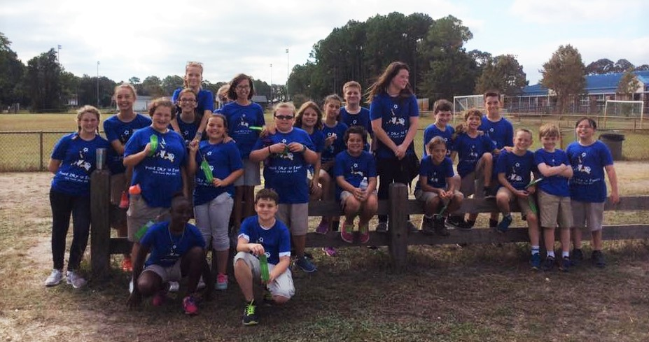

Stay in the Know…
Calendar Events
- Tuesday, Nov. 1, will be the chapel service that kicks off our Operation Christmas Child mission emphasis. Please help us teach the children of FCS the importance of giving to others and sharing the Gospel by filling a shoe box.

- Tuesday, November 8, is the General Election for the United States. Please vote.

- Friday, November 11, is Veterans’ Day. Come to a special program honoring those who served at 8:15 A.M. in the auditorium.

- Thursday, November 10, deadline for shoe box gift items. Please have all your shoe box items turned in by this date.

Newsletter continued on page 2

Inside This Issue
Community Helpers
School Improvements
Samaritan’s Purse
Field Day
Stay in the Know
Class Spotlight
Words of Wisdom

- A shoe box packing party is planned for Tuesday, November 15, during our regularly scheduled chapel service. Ask your child’s teacher how you can be a part of this awesome event.

- Friday, November 18, shoe box send off. Students will pray over and load packed gift boxes. Boxes will then be taken to a collection point to be shipped to Samaritan’s Purse distribution center. Our boxes will then travel around the world!

- The first and second grade classes will proudly present The First Thanksgiving, a reenactment of the very first celebration of thanks by the Pilgrims and Indians. The program will begin promptly at 8:30 A.M.

- Tuesday, November 22, is early dismissal for all FCS students. Marvin Wing will dismiss at 11:00 A.M. and Godfrey Hall Students will dismiss at 11:15 A.M. This early dismissal marks the beginning of Thanksgiving Break. School will reconvene on Monday, November 28, at 8:00 A.M.

Class Spotlight

5th Grade Class Studies Jamestown

Fifth grade students have been learning about early settlers during history class. To commemorate this historic time era, students built a model of the Jamestown settlement. Well done 5th grade!

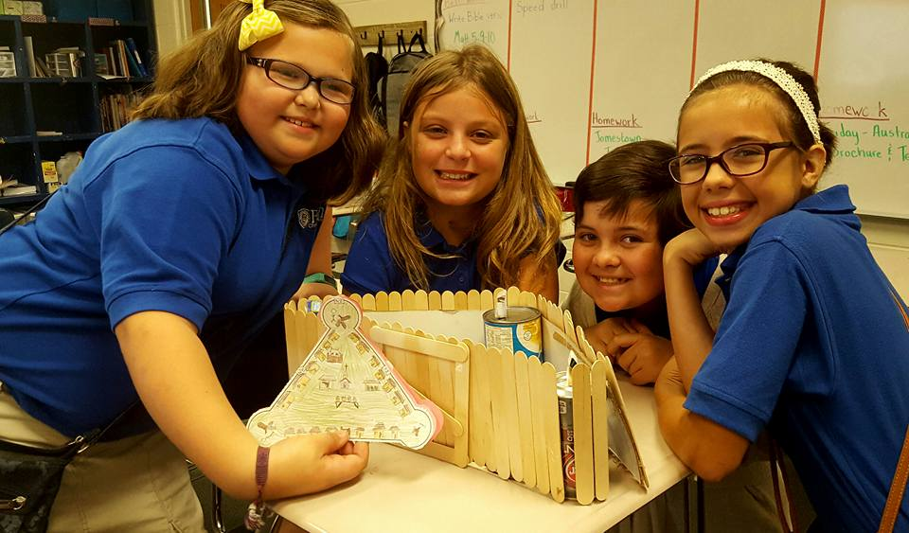

Words of Wisdom

Proverbs 23:4-5
⁴ Do not wear yourself out to get rich;
do not trust your own cleverness.
⁵ Cast but a glance at riches, and they are gone, for they will surely sprout wings
and fly off to the sky like an eagle.

Like us on Visit our web site: www.faithchristianpsj.net
Continued from page 1

